**Internet Gateway (IGW)**

Create internet gateway in aws console:

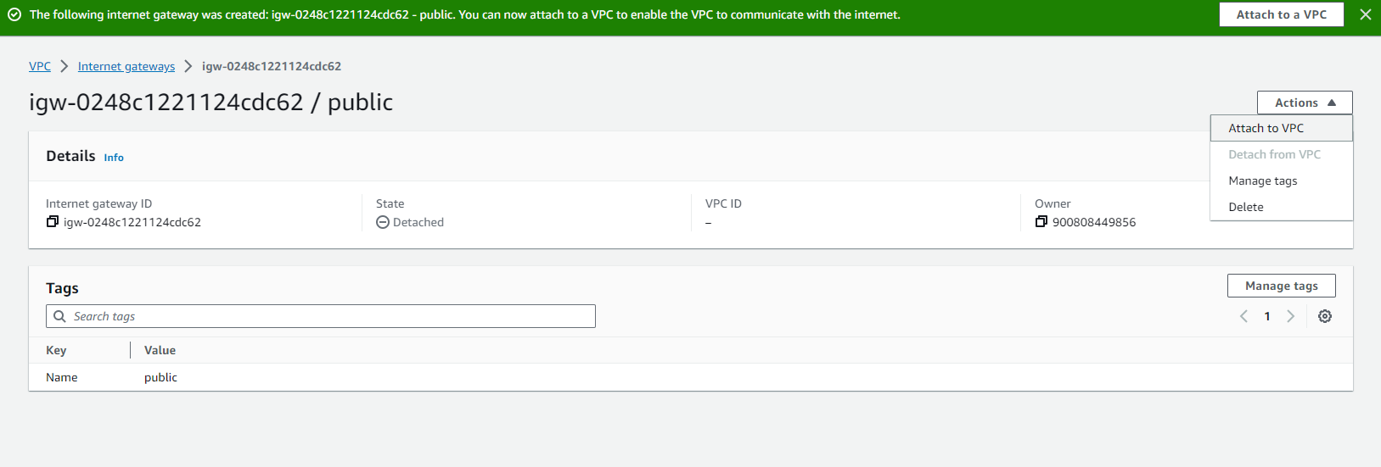

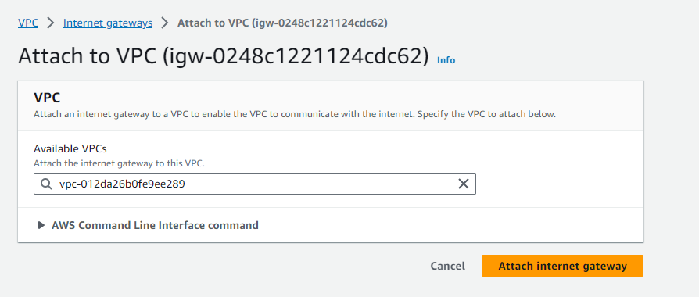

Then attach to vpc that have a public subnet without nat gateway or internet gateway

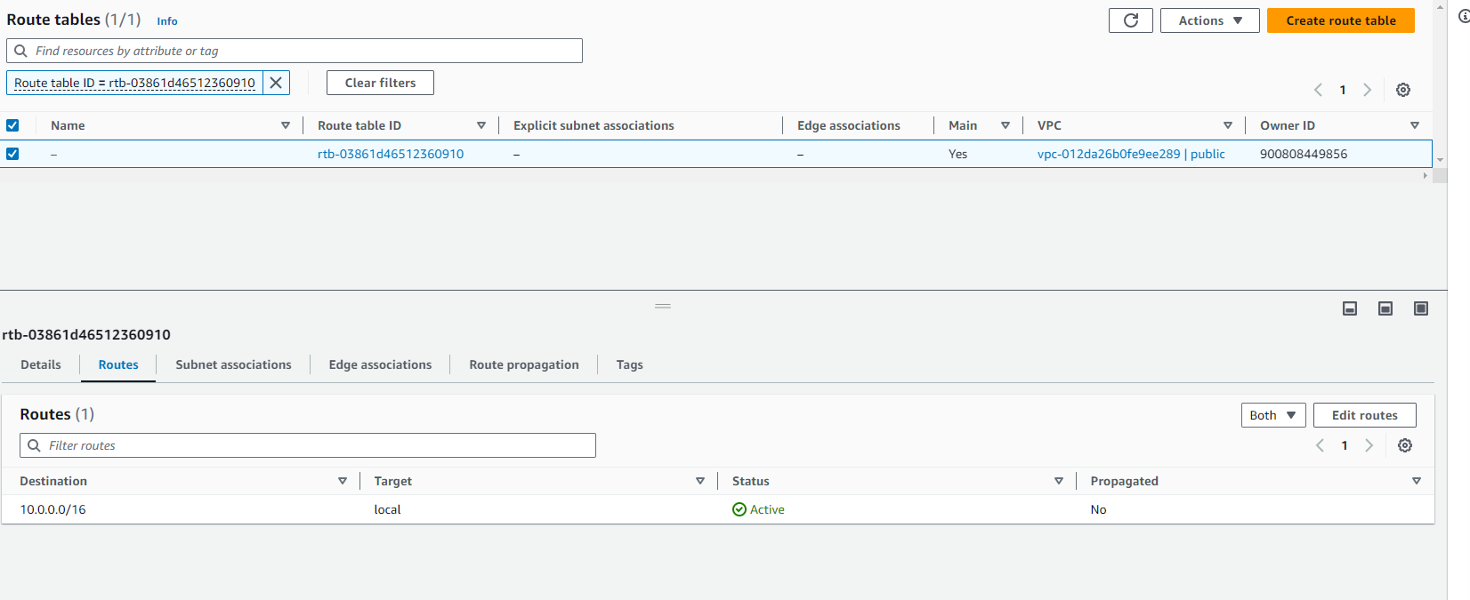

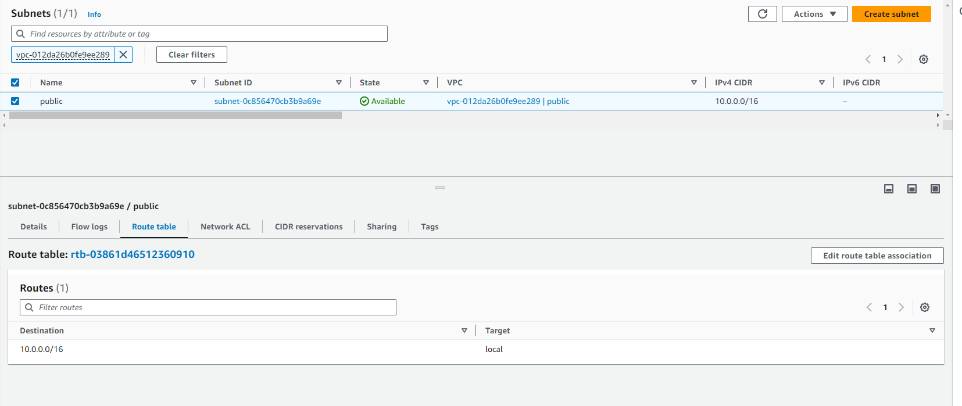

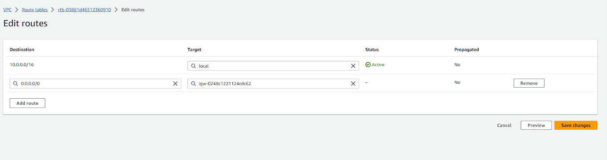

From <[*https://nlbsg.udemy.com/course/aws-certified-solutions-architect-associate-saa-c03/learn/lecture/13528544#overview*](https://nlbsg.udemy.com/course/aws-certified-solutions-architect-associate-saa-c03/learn/lecture/13528544#overview)>